**Test report – Centaurus dashboard deployment & deployment of Arktos Cluster without Mizar**  **CNI**

**on Premise**

This document captures the steps to deploy an Arktos cluster lab without Mizar CNI. The machine in this lab used are **16 GB RAM, 16 vCPUs, 128 GB storage, and Ubuntu 18.04 LTS.**

Date-28 Dec. 2021

# Step-1: Update kernel (If required)

To check kernel, run following command

uname -a

|  |  |
| --- | --- |
| wget https://raw.githubusercontent.com/CentaurusInfra/mizar/dev-next/kernelupdate.sh | |
| sudo bash kernelupdate.sh |  |

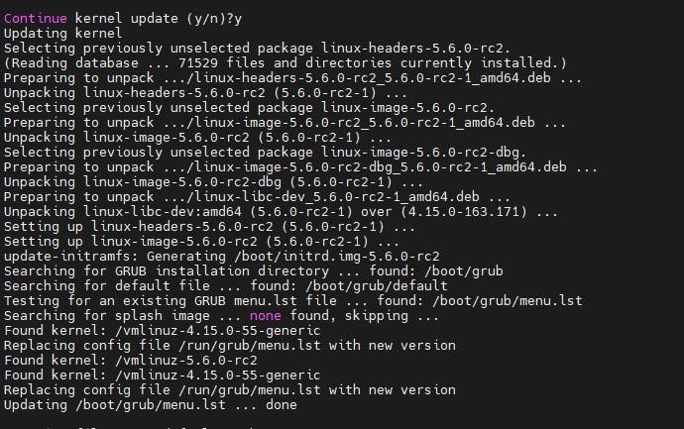

# Step-2: Install dependencies

Run the following steps to install dependencies required for arktos deployment:

git clone [https://github.com/Click2Cloud-Centaurus/arktos.git ~/](https://github.com/Click2Cloud-Centaurus/arktos.git)go/src/k8s.io/arktos

cd ~/go/src/k8s.io/arktos

sudo bash ./hack/setup-dev-node.sh

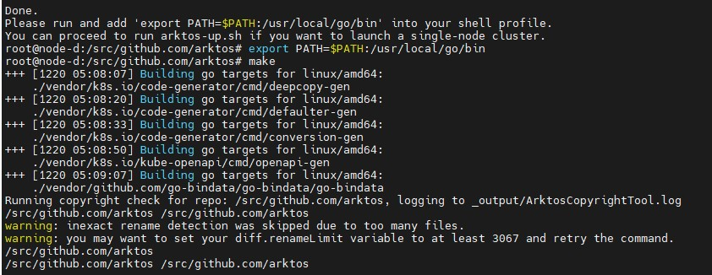

**Run Arktos**

The easiest way to run Arktos is to bring up a single-node cluster in your local development box:

echo export PATH=$PATH:/usr/local/go/bin\ >> ~/.profile

echo cd \$HOME/go/src/k8s.io/arktos >> ~/.profile

git checkout -b master

source ~/.profile

hack/arktos-up.sh

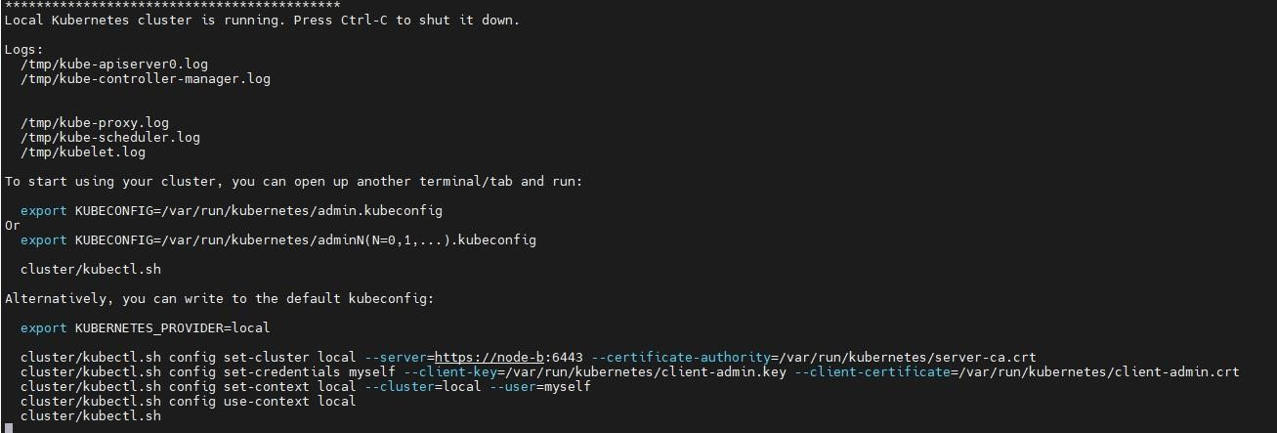

1. **Check nodes status:**

./cluster/kubectl.sh get nodes

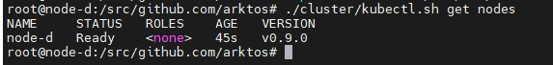

1. **Check pods status:**

./cluster/kubectl.sh get pods -Ao wide



**Deployment of Centaurus dashboard:**

Link for YAML file of the dashboard:

<https://click2cloud-my.sharepoint.com/:u:/g/personal/amit_nagpure_click2cloud_net/EdmJx0itP0RGl8WqAVVplbwBurpul2EhSi3_Uj-d8xy7zQ?e=RBij9E>

Create YAML file naming ‘kubernetes-dashboard.yaml’ change image c2c/…..0.6.4

and in args input ‘—authentication-mode=basic’

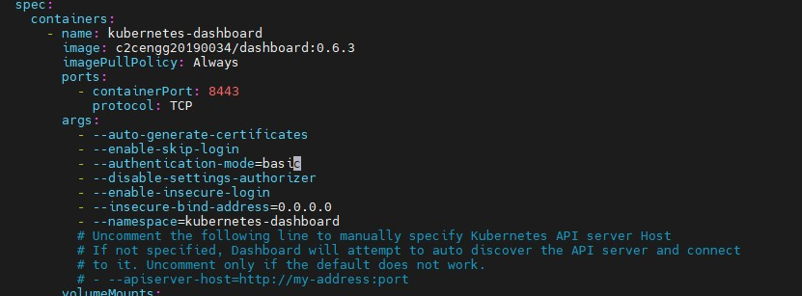

Input the following commands before deploying the dashboard:

git checkout -b test

|  |
| --- |
| sudo sed -i '0,/RANDFILE/{s/RANDFILE/\#&/}' /etc/ssl/openssl.cnf |
| openssl genrsa -out dashboard.key 2048 |  |

openssl rsa -in dashboard.key -out dashboard.key

|  |  |
| --- | --- |
| openssl req -sha256 -new -key dashboard.key -out dashboard.csr -subj "/CN=$(hostname -I | awk | |
| '{print $1}')" |  |

openssl x509 -req -sha256 -days 365 -in dashboard.csr -signkey dashboard.key -out dashboard.crt

./cluster/kubectl.sh create namespace kubernetes-dashboard

./cluster/kubectl.sh create secret generic kubernetes-dashboard-certs --fromfile=$HOME/dashboard.key --from-file=$HOME/dashboard.crt -n kubernetes-dashboard

./cluster/kubectl.sh create -f kubernetes-dashboard.yaml

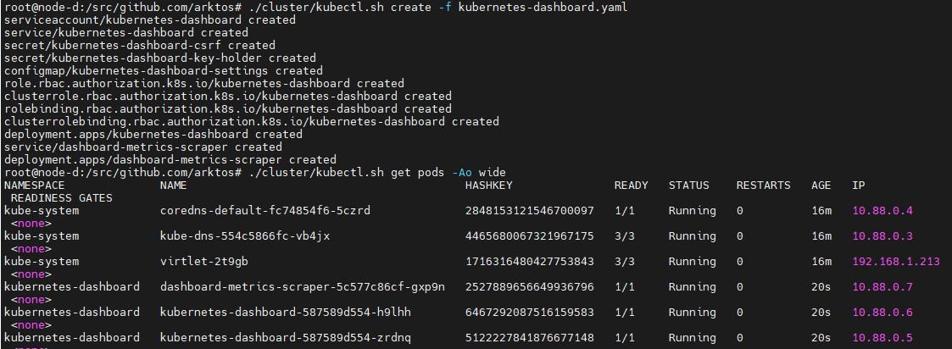

Create the Kubernetes Dashboard password file:

mkdir -p /etc/kubernetes/auth

vi /etc/kubernetes/auth/auth.csv

Here is the file content: adminpass,admin,admin,system:masters

we need to configure while deploying the arktos the following entry in ‘common.sh’

|  |  |
| --- | --- |
| vi /hack/lib/common.sh |  |
| 350 - --basic-auth-file=/etc/kubernetes/auth/auth.csv | |

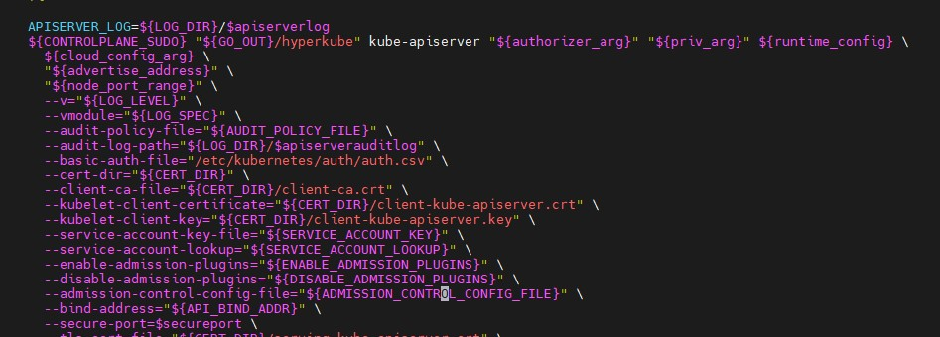

Now re-run the arktos script:

hack/arktos-up.sh

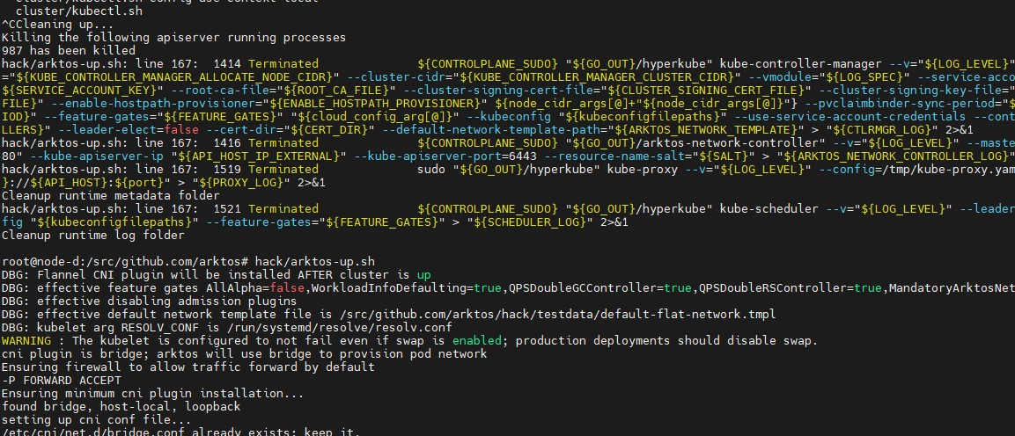

Now re-deploy the kubernetes-dashboard file:

The Dashboard will be accessible at

https://<host_machine_ip>:3000

1

and you can log in

using

username

&

password

used in

auth.csv

